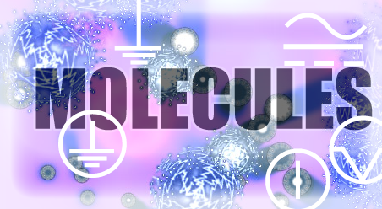

GAME DESIGN DOCUMENT V 1.0

DOCUMENT OVERVIEW

GAME DESIGNER: Amitesh Bhattacharyya

DATE: 13th June 2012

LAST MODIFIED: 20th June 2012

VERSION: 2.0

DOCUMENT HISTORY:

[This section of the document will list out the edited updates to the current version from the previous one.]

**VERSION 2.0**

**DATED: 13th June 2012**

* Story introduced
* More cell categories outlined
* Enemies Added
* Game play added
* Level objectives updated
* Game modes introduced

2.0.0 GAME OVERVIEW

WORKING TITLE: MOLECULES

GENRE: CASUAL

PLATFORM: i-phone

CORE GAMEPLAY: 2 finger Touch > Pinch

No. Of GAME MODES: INTERN (time based) / SCIENTIST (Level Based)

No of Levels:

Total Game hrs:

2.1.0 STORY OVERVIEW

Colonization of nearby planets is inevitable due to dying resources on earth. A comprehensive experiment is being conducted to study the cellular composition of other planets and its compatibility with earthly composites.

Control, fuse, cure, create and / or destroy alien virus cells to support human life on other planets. The future depends on it.

3.0.0 GAME DESCRIPTION

3.1.0 SPLASH SCREEN INTRO

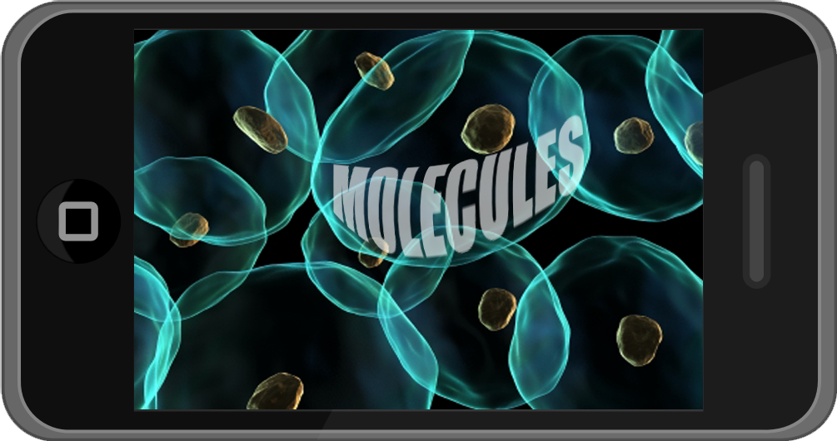The intro screen will be animated with fluorescent cells in constant motion. The title “MOLECULES” will be engraved on one of the molecules in the center. The molecules will move animatedly due to collision amongst themselves.

3.2.0 GAME MODES

The player can approach the game in 2 modes depending on game play.

* INTERN (TIME BASED GAME PLAY)
* SCIENTIST (LEVEL BASED GAMEPLAY)

INTERN

In this mode the player will have to control the population of the cells and / or survive viral attacks till time runs out.

The level progression in this mode will depend on the cells division and time taken to divide.

SCIENTIST

In this mode the player will have to clear all stages of a particular level to unlock the next level.

There are 4 LEVEL OBJECTIVES in this mode. The level objectives will also outline the story as mentioned in the STORY OVERVIEW section.

3.3.0 GAME PLAY SUMMARY

The player can do the following actions to win the game.

MOVE

The player can move a cell by touching and sliding it. Using this action, the player can avoid level obstacles and other hostiles.

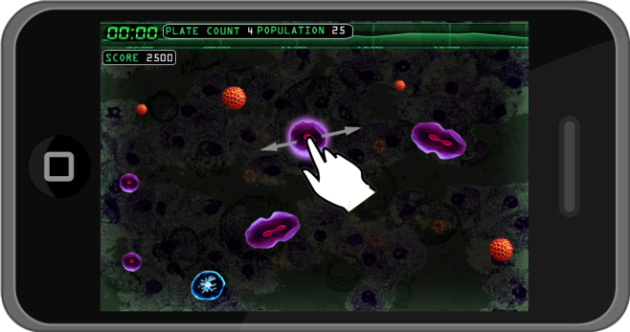

POPULATION CONTROL

The HOST CELLS will multiply through binary fission. The player can control the population by touching 2 offsets of a HOST CELL type before it assumes its original size and pinch. To successfully fuse 2 cells, the player must touch 2 offsets together.

This action is reversible (see Fig Below)

POPULATING

The player can populate the cells by manually dividing the cells.

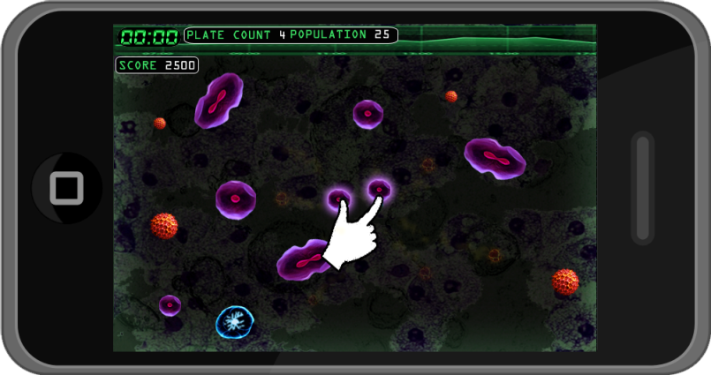

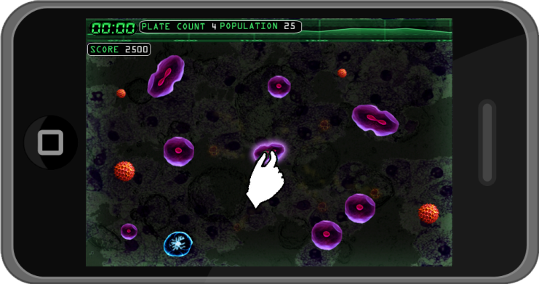

CURING AN INFECTED CELL

The HOST CELLS might get infected by VIRUS CELLS.

The player can cure an infected cell by joining a CURE CELL with any infected cell to reverse its effects.

PRODUCE CURE CELLS

During ongoing game play, the VIRUS CELLS might affect the CURE CELLS.

The player can produce a cure cell by joining cells in a particular series relative to the current level.

EXAMPLE:

2 TYPE A cells + 1 TYPE B cells = 1 Cure cell

ATTACK VIRUS CELLS

The player can attack a VIRUS CELL type with a MECENARY HELPER CELL. The player will have to touch and push the MERCENARY CELL towards a VIRUS CELL.

The MRECENARY CELL will gain momentum and destroy a VIRUS CELL if it comes in its path.

3.4.0 GAME FLOW

SPLASH SCREEN INTRO

GAME MODE SELECTION

SCIENTIST

INTERN

LEVEL SELECTION MENU

LEVEL OBJECTIVES

GLOBAL OBJECTIVE

ALL STAGES CLEAR

STAGE SELECTION MENU (UNLOCKABLE)

STAGE OVER

LEVEL OVER

GAME OVER

4.0.0 GAME ELEMENTS

4.1.0 HUD

The HUD band will be placed at the top of the game window and will display the following during game play as stated below.

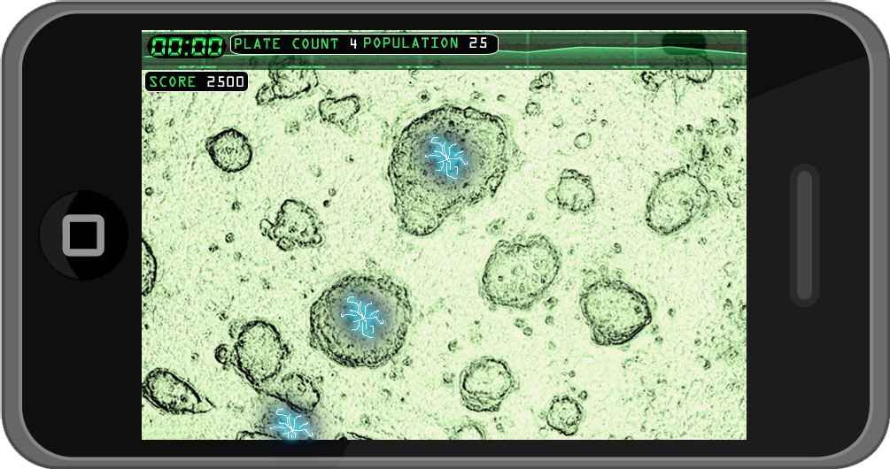

4.1.1 REMAINING TIME

This HUD will display a countdown timer in seconds and denote the remaining time for a current level or time elapsed to complete level objective.

4.1.2 SCORE

This HUD will display the score of successful attempts to fuse and / or cure the cells.

4.1.3 POPULATION

The POPULATION is the current count of the cells during game play. This HUD will have 2 sub headers as follows

CURRENT COUNT: This tab will display the current population of the cells

PLATE COUNT: This tab will display the initial count at the beginning of the current level.

4.2.0 CELL TYPES

The cells are broadly classified into 3 categories.

1. HOST CELLS

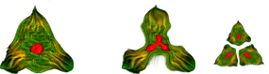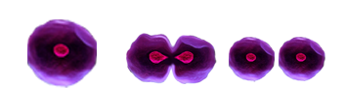The HOST CELLS are the only cells that will undergo fission i.e. break into 2 offsets. The cells can break into 2, 3 or 4 offsets. The central nucleus will always divide first giving a hint of the cell about to undergo division. The stages of offset division are graphically depicted below.

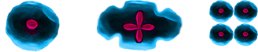

3OFFSET DIVISION

4 OFFSET DIVISIONS

2 OFFSET DIVISIONS

There will be various types of cells depending upon shape color and number of offsets.

**CELL TYPE EXAMPLES**

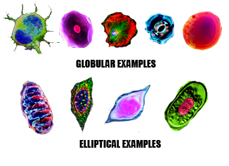

1. HELPERS

The helper cells will aid the player during game play against virus attacks and other obstacles. The helper cells will have a distinct look to distinguish from other cells and will have cool colors.

* 1. BINDER CELL

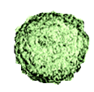

The BINDER CELL will delay the fission process by a few seconds. The player can use this cell to stop a cell from diving further and use the time lapse to join a cure cell, etc.

The player can only use the BINDER CELL on a full grown cell and not a growing offset.

The player cannot create a BINDER CELL. But each time a BINDER CELL is used, a new BINDER CELL will be introduced into the level after a time lapse.

* 1. SHIELD CELL

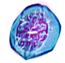The SHIELD CELL will cover the infected cell for some time to protect it against virus attacks.

The SHIELD CELL will cover the host cell with tiny globular cells for protection against VIRUS CELLS and other obstacles as shown graphically below.

The player will not be able to produce any SHIELD CELLS. But the SHIELD CELLS will restore its health after the shield effect has worn off.

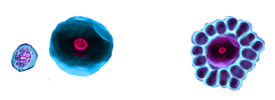

* 1. CURE CELL

cure.PNGThe CURE CELL will heal an infected cell. This type will limited per level and will have characteristic look as shown graphically.

Some VIRUS CELLS can consume a HOST CELL and turn it into a VIRUS CELL.

A CURE CELL can undo the effects of a VIRUS CELL before the effect of the VIRUS CELL takes over.

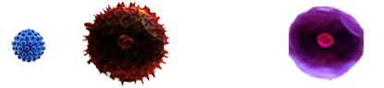

The player can also make CURE CELLS.

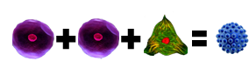The player will have to combine cells in strict order of succession to make a CURE CELL during ongoing game play.

* 1. MERCENARY CELL

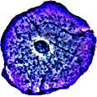

The MERCENARY CELL can destroy a VIRUS CELL.

This cell will be not be available in the game. But the player can create it by adding a series of cells in strict order of succession (see equation below).

Joining a MERCENARY with a VIRUS CELL will rupture the latter and destroy it. A single MERCENARY CELL can destroy only one VIRUS CELL.

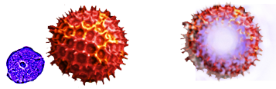

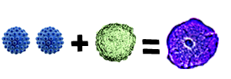The player can also create a FIGHTER CELL by combining 2 CURE CELS with 1 BINDER CELL.

* 1. ELECTRIC CELLS

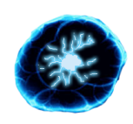Touching 2 ELECTRIC CELLS will create a line of electricity between the cells. The player can use this function to eliminate VIRUS CELLS.

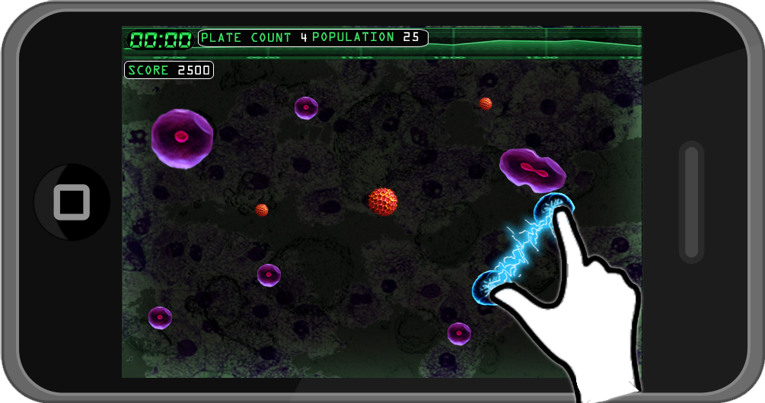

**NOTE: The HOST CELLS will divide faster if it touches the electric line. The player will have to maneuver the HOST CELLS to avoid this.**

1. VIRUSES

The VIRUS CELLS are hostiles in the game. They will have warm or hot colors and will be characterized by a spiky exterior.

* 1. BLASTIS VIRUS

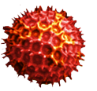The BLASTIS VIRUS is smaller than the HOST CELLS but will gradually expand and grow to assume the size of the HOST CELLS.

Once it has reached its maximum size, it will explode after a slight wobble movement. The fragments will dissolve after travelling a distance.

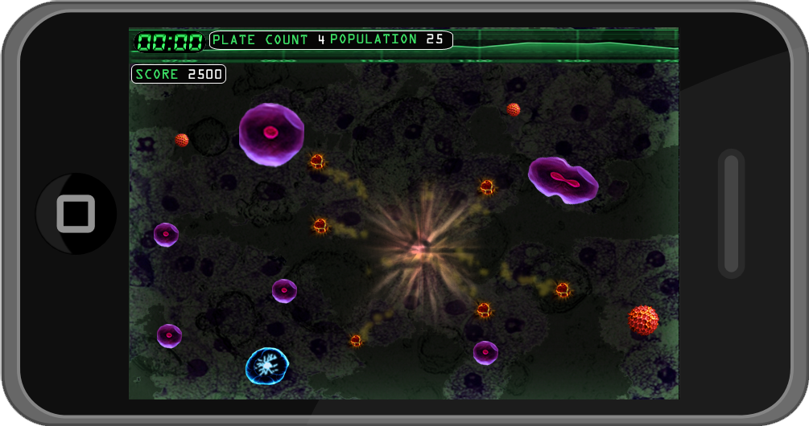

The exploding fragments will split up any HOST CELLS into multiple offsets if it comes in contact before it dissolves thus increasing the population.

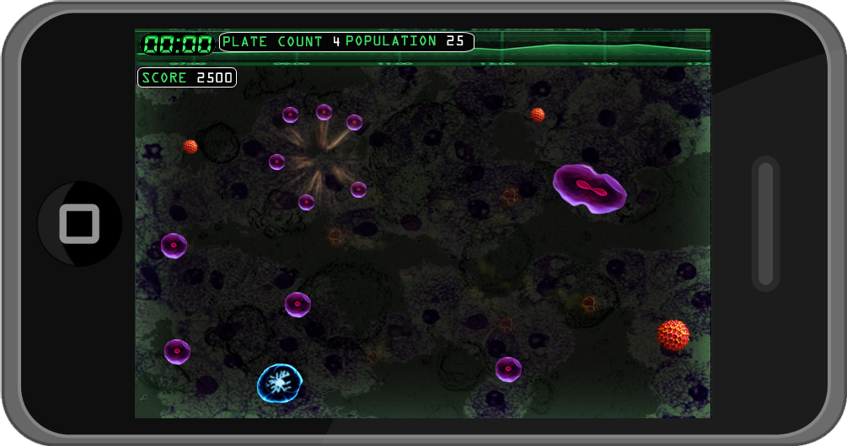

**NOTE: Only the exploding fragments will interact with the HOST CELLS. On regular contact, the BLASTIS VIRUS will have no effect on the HOST CELLS and will merely keep floating till it explodes.**

* 1. INFECTOR VIRUS

The INFECTOR VIRUS will be the same size as that of the HOST CELLS and will have faster movements than the HOST CELLS. The INFECTOR VIRUS will consume any cell in its path and convert it into its own kind but will not effect on other VIRUS CELLS.

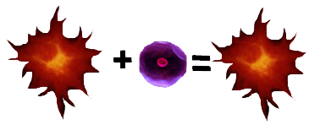

.

This virus cannot be cured with a CURE CELL but can get destroyed if comes under any electricity. The player can use the ELECTRIC CELLS against this type of virus.

* 1. COSUMATOR VIRUS

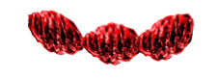This virus will consume all cell types (HOST & HELPERS) and attach the cells like a snake. The player can use CURE CELLS to liberate consumed cells and use ELECTRIC CELLS to destroy it.

4.3.0 OBSTACLES

4.3.1 PLASMA WALL

The PLASMA WALL will multiply any HOST and / or VIRUS CELLS and double their population but will have no effect on HELPER CELLS.

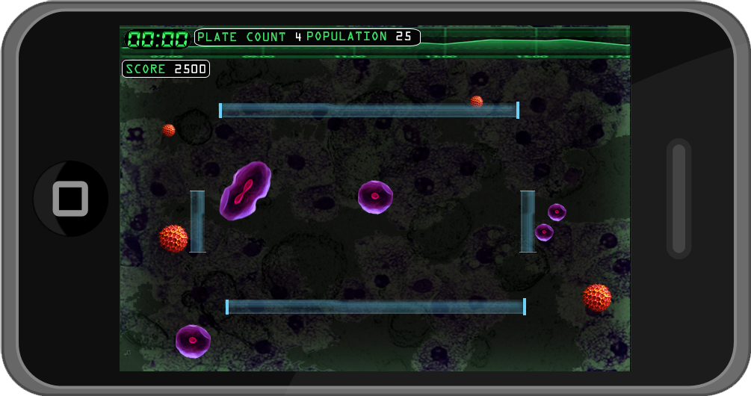

4.3.2 ELECTRIC FENCE

Electric Nodes will be scattered in any particular level. The electrodes will be joined together with a line of electricity creating an ELECLTRIC FENCE.

At any given time, only 2 nodes can connect to make an ELECTRIC FENCE. The nodes can connect laterally and diagonally to make the ELECTRIC FENCE.

The ELECTRIC FENCES will only connect periodically at random during game play.

On coming under direct contact with the ELECTRIC FENCE, HOST CELLS and VIRUS CELLS will multiply, but HELPER CELLS will be DESTORYED. The player cannot destroy the nodes. Rather the player will have to avoid the ELECTRIC FENCES.

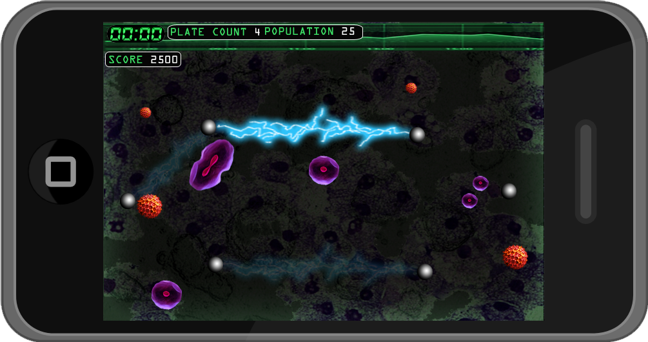

4.0.0 GAME MECHANICS

4.1.0 CELL BEHAVIOUR (GLOBAL)

All cell types will have the flowing states

1. ORIGINAL or MATURED

* This will be default state of the cells.

1. GLOW

* The cells will display this state each time the player touches a cell to move, combine, etc. It will remain stuck for some time and release itself and return to ORIGINAL or MATURED state.

1. FUSED

* This state is temporary and will appear each time 2 cells are fused to create a HELPER CELL. If the player does not fulfill the combination, it will return to ORIGINAL / MATURED state.

1. OFFSET (ONLY HOST CELLS)

* The offsets are created each time a HOST CELL undergo division.
* The offsets will be smaller and grow till it reaches its ORIGINAL state.
* The colors of the offsets will be less bright than its ORIGINAL state and will regain its brightness once it reaches maturity.

4.2.0 HOST CELLS

4.2.1 FISSION

* The HOST CELLS will undergo fission and break into 2 or more offsets.
* An electrical park animation will let the player know of the cells about to undergo fission.
* The electric spark will continue till the cell is broken down into 2 or offsets.
* The player action will be restrained during the electrical progress i.e. the player will not be able to fuse the offsets during this time and will have to wait till it breaks into two offsets.
* Moving the cell during this progress will also drag the offset till the whole animation is complete.
* The offsets will be smaller than the parent cell and will grow till it reaches the same size or maturity.
* The cells cannot undergo fission till they have reached the original size.
* The player during this time can move the smaller offsets by touch to avoid obstacles and hostiles.
* The player must fuse the 2 cell offsets before they reach maturity.
* The color saturation of the offsets will be lower than a matured HOST CELL and will regain full saturation once it reaches maturity.

|  |  |  |  |
| --- | --- | --- | --- |
| **TYPE** | **SHAPE** | **OFFSETS** | **TIME (in sec)** |
| I | Globular | 2 | 1 |
| II | Globular | 2 | 0.5 |
| III | Globular | 2 | 0.25 |
| IV | Elliptical | 2 | 1 |
| V | Elliptical | 3 | 0.5 |
| VI | Capsular | 3 | 1 |
| VII | Capsular | 4 | 0.5 |

**NOTE**: The HOST CELLS can break off into more than the number indicated above due to VIRUS CELL attacks and / or ELECTRICITY. TIME is subject to game testing.

4.2.2 CELL INTERACTION

* All the cells will give a glow around its circumference each time the player will interact with it.
* MOVING A CELL
  + The player can move any HOST CELL and / or HELPER CELLS by touching and sliding it in the desired direction.
  + The player cannot interact with any VIRUS CELLS. In order to attack a VIRUS CELL, the player will have to touch and slide to give momentum to the MERCENARY CELL.
* COMBINING OFFSETS
  + The player **MUST** touch 2 offsets or cells and pinch to fuse the two before they reach maturity.
  + The player can fuse only 2 offsets per action independent of the total number of offsets the primary cell might give.
  + Once a cell is fused, it will stand as a unit only for a few seconds and repeat the fission process after it reaches maturity.
  + The player can use this mechanics to make CURE CELLS and / or attack VIRUS CELLS.
* POPULATE
  + In the INTERN GAME MODE, the player will have to populate the plate.
  + The player can divide a HOST CELL by touch it at the 2 ends of a HOST CELL and expanding it till it breaks into 2 offsets.
* PRODUCING
  + The player can use the same action to combine cells to produce CURE CELLS and / or MERCENARY CELLS.
  + FOR CURE CELLS
    - The player will have to combine 2 cells of the same type to make a CURE CELL.
    - Each time the player combine 2 HOST CELLS, the new cell will give out a glow to suggest the addition.
    - The glow state will stand for some time and return to its original state if there is no interaction.
    - Combining another HOST CELL TYPE during the glow stat will yield a CURE CELL.
  + FOR MERCENARY CELL
    - To yield a MERCENARY CELL, the player must combine 2 CURE CELLS with 1 BINDER CELL.
    - The 2 CURE CELLS when added will give out a glow and stand for some time.
    - But unlike HOST CELLS used to create CURE CELLS, the 2 CURE CELLS will become 1 after the GLOW STATUS.
    - Combining a BINDER CELL to the combined CURE CELLS during the GLOW STATE will yield a MERCENARY CELL.

4.2.3 INTER CELL COLLISION

* The HOST CELLS will have continuous motion.
* On collision with other host cells, the cells will bounce off each other in smooth transition.
* The cells will not fuse amongst themselves.

4.3.0 HELPERS

The HELPER CELLS will be sprawled at random across a level and / or will be limited per level. The HELPER CELLS can be fused into any HOST CELL using the same action of touch and pinch. Their individual actions are discussed below.

4.3.1 BINDER CELL

Fusing this cell with a matured HOST CELL will delay the fission process of that particular cell by a few seconds thus giving time to the player to strategize other cell fusions.

A BINDER CELL can be used on a matured HOST CELL only and not their offsets.

4.3.2 SHIELD CELLS

The SHIELD cell will create a protoplasmic cover over a HOST CELL and protect it from further breakage during VIRUS explosions and other hostiles.

The HOST CELL will move slower than its original speed during the SHIELD effect.

The player cannot produce any SHIELD CELLS.

Once the effect of the SHIELD CELL wears off, the tiny cells that made the cover will regroup and regain its original SHIELD CELL state after a time lapse.

An electric charge in the nucleus will display the readiness of the cell.

The SHIELD CELLS can only get destroyed by the ELECTRIC FENCES.

4.3.3 CURE CELLS

CURE CELLS are self explanatory and will cure any infected cell.

The player can generate more CURE CELLS by combining 2 cell types and adding another cell type.

Adding a cure cell to an infected cell will return the cell to its original state.

4.3.4 MERCENARY CELLS

This type of cell will not be available in the game. But the player can create it by combining 2 CURE CELL and 1 BINDER CELL.

Only MERCENARY CELLS can attack VIRUS CELLS.

To attack VIRUS CELLS, the player will have to touch and push the MERCENARY CELL in the desired direction.

The MERCENARY CELL will travel with momentum in that direction of the push and destroy any VIRUS CELLS in its path.

This type of cell will have effect on other HELPER CELLS and HOST CELLS.